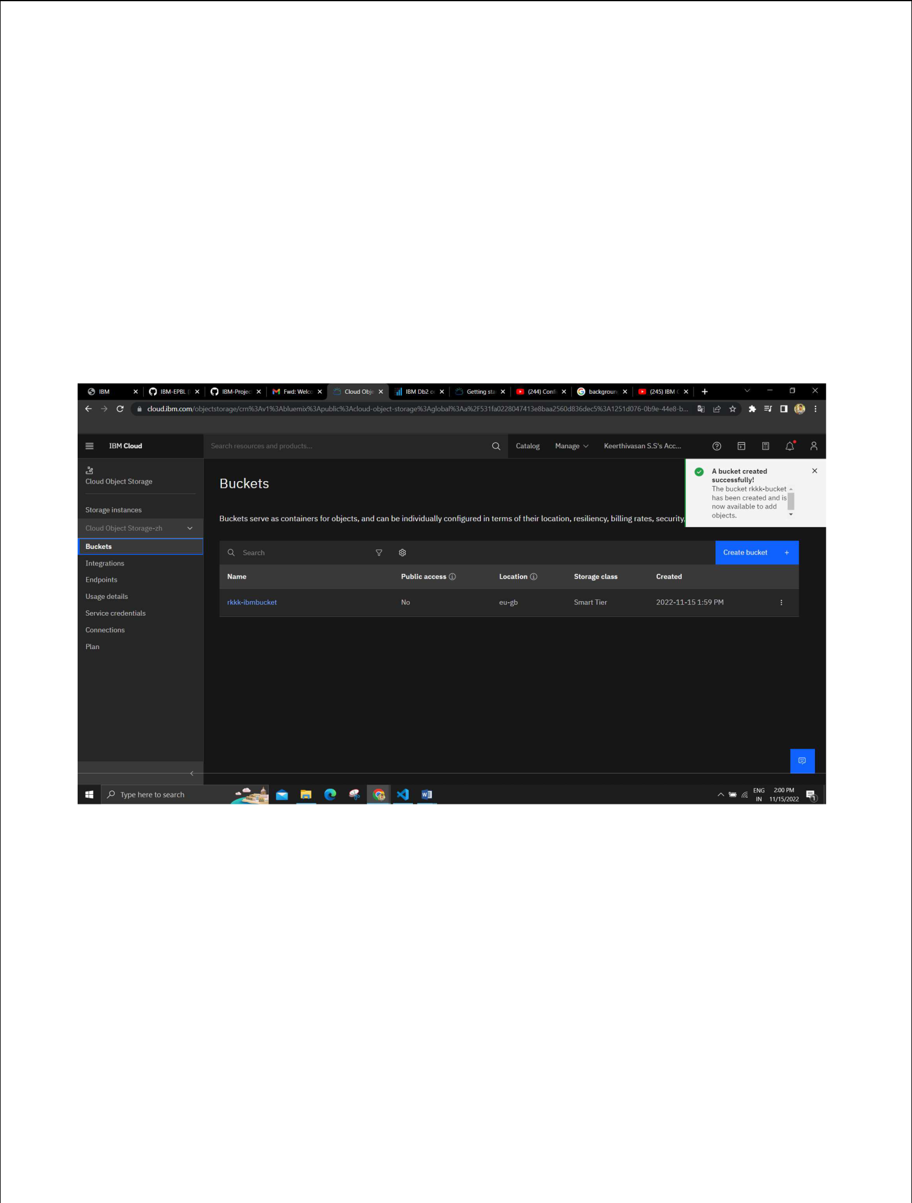
Assignment 3

Inventory Management System:

Team ID : PNT2022TMID05660

Name : Mohamed Fazil

1. Create a Bucket in IBM object storage.
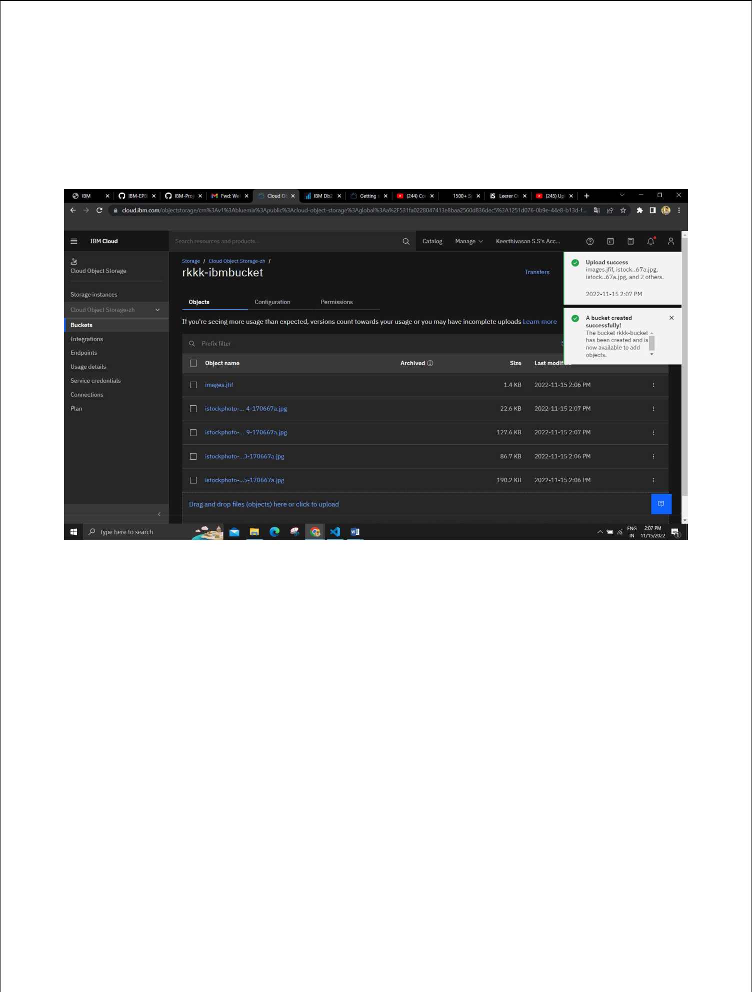

- Upload an 5 images to ibm object storage and make it public. write html code to displaying all the 5 images.
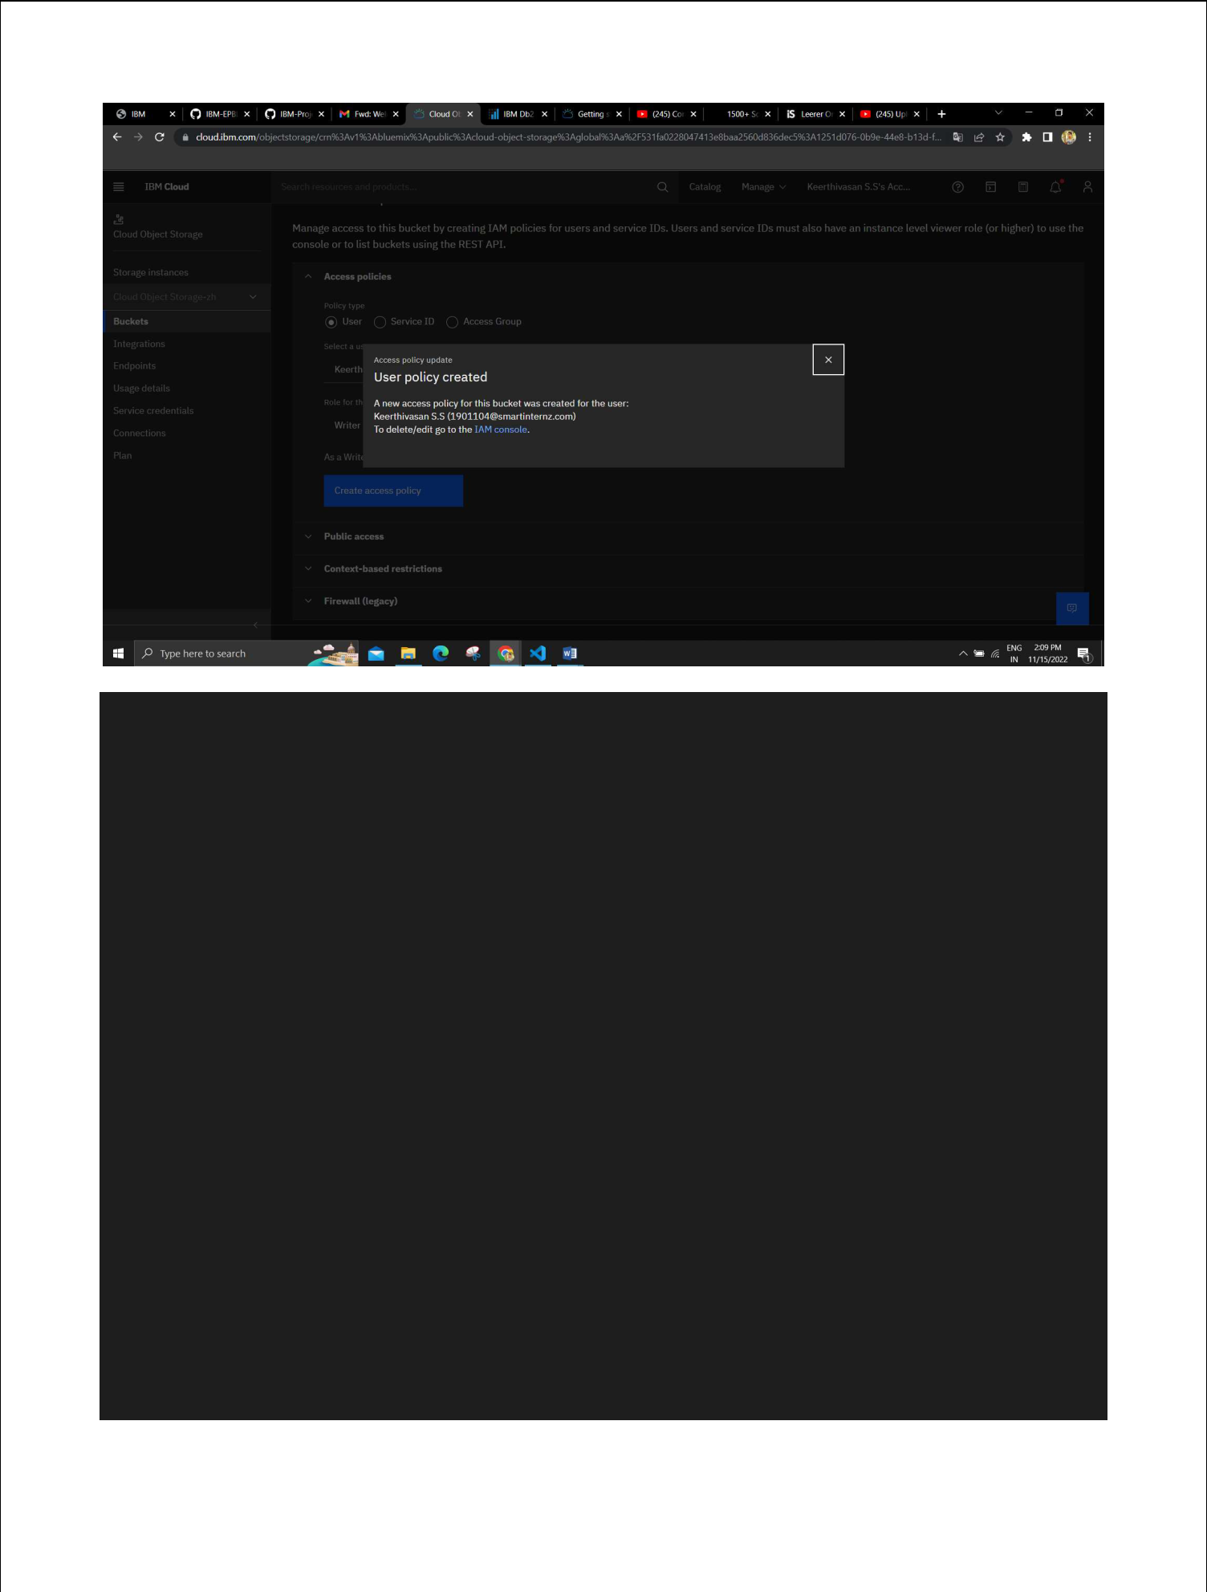

<!DOCTYPE html>

<html>

<head>

<title>HTML Cloud Storage Buckets</title>

</head>

<body>

<div class="container">

<img src =

"C:\Users\Sabari\Desktop\IBM\istockphoto-157580200-170667a.jpg" alt = "image1"

height = "250" width = "270" />

<img src =

"C:\Users\Sabari\Desktop\IBM\istockphoto-1196215434-170667a.jpg"alt = "image2"

height = "250" width = "270" />

<img src =

"C:\Users\Sabari\Desktop\IBM\istockphoto-1436709759-170667a.jpg"alt = "image3"

height = "250" width = "270" />

<img src =

"C:\Users\Sabari\Desktop\IBM\istockphoto-157580200-170667a.jpg"alt = "image4"

height = "250" width = "270" />

<img src =

"C:\Users\Sabari\Desktop\IBM\istockphoto-509894935-170667a.jpg"alt = "image5"

height = "250" width = "270" />

</div>

</body>
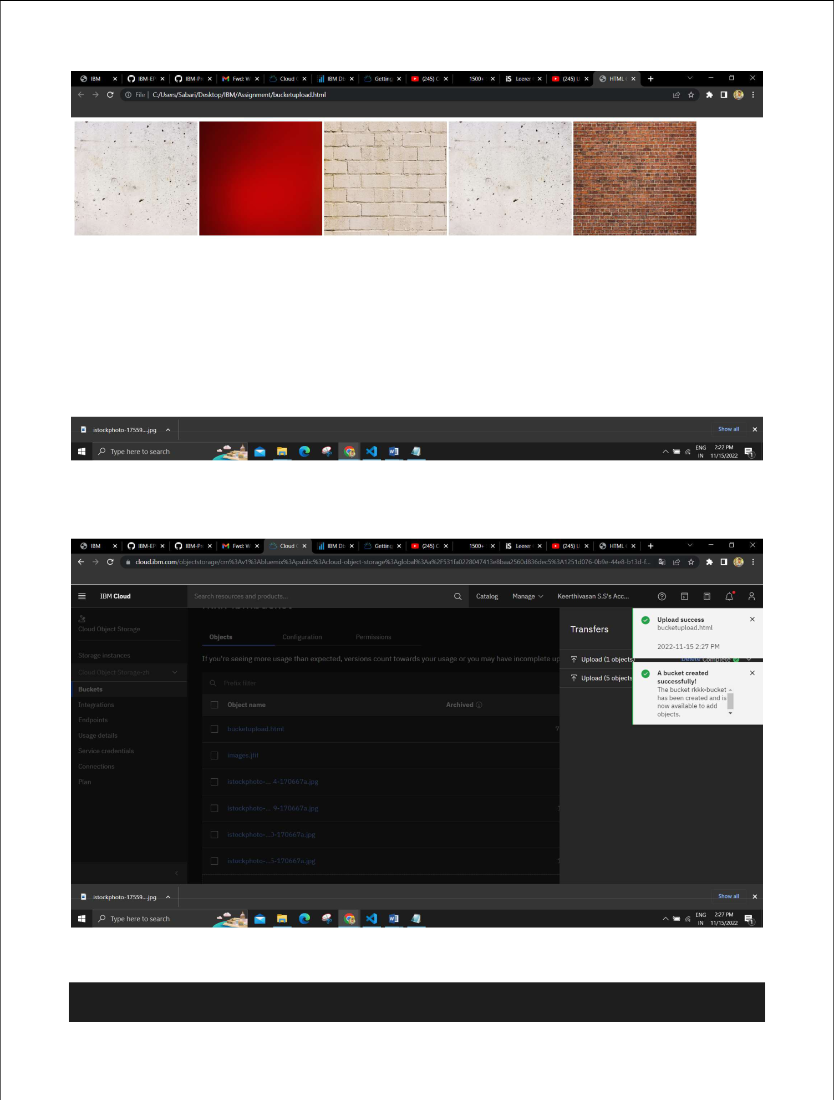

- Upload a css page to the object storage and use the same page in your HTML code.

<!DOCTYPE html>

<html>

<head>

<title>HTML & CSS Cloud Storage Buckets</title> <style>

h1{

color: white;

text-align: center;

font-weight: bold;

font-family: Bodoni Mt;

}

</style>

<link rel="stylesheet" href="./CssProperty.css">

</head>

<body>

<h1 >UNIVERSE OF GALAXIES</h1>

<div class="background">

<img src =

"C:\Users\Sabari\Desktop\IBM\istockphoto-157580200-170667a.jpg"alt = "image1"

height = "250" width = "270" />

<img src =

"C:\Users\Sabari\Desktop\IBM\istockphoto-1196215434-170667a.jpg"alt = "image2"

height = "250" width = "270" />

<img src =

"C:\Users\Sabari\Desktop\IBM\istockphoto-1436709759-170667a.jpg"alt = "image3"

height = "250" width = "270" />

<img src =

"C:\Users\Sabari\Desktop\IBM\istockphoto-157580200-170667a.jpg"alt = "image4"

height = "250" width = "270" />

<img src =

"C:\Users\Sabari\Desktop\IBM\istockphoto-509894935-170667a.jpg"alt = "image5"

height = "250" width = "270" />

</div>

</body>

</html>

Uploaded Images:
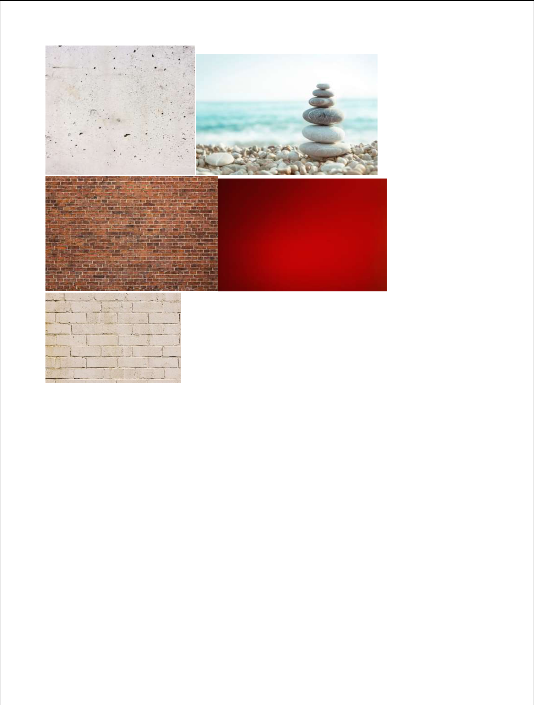

- Design a chatbot using IBM Watson assistant for hospital. Ex: User comes with query to know the branches for that hospital in your city. Submit the web URL of that chat bot as a assignment.

url :

https://web-

chat.global.assistant.watson.appdomain.cloud/preview.html?backgroundImag

eURL=https%3A%2F%2Fus-

south.assistant.watson.cloud.ibm.com%2Fpublic%2Fimages%2Fupx-

6fc9dc5a-aa0d-4a6e-b958-1da167683ee3%3A%3A12469e8d-1735-412d-8e42-

df538344de03&integrationID=3dda54c3-0aef-465d-b5e2-

81b3f4e1e9cb&region=us-south&serviceInstanceID=6fc9dc5a-aa0d-4a6e-

b958-1da167683ee3
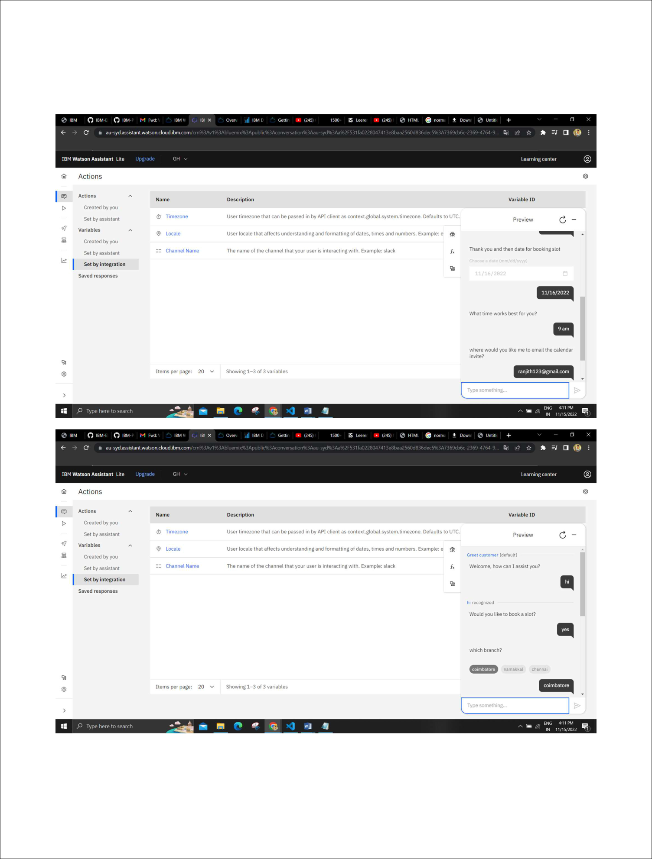
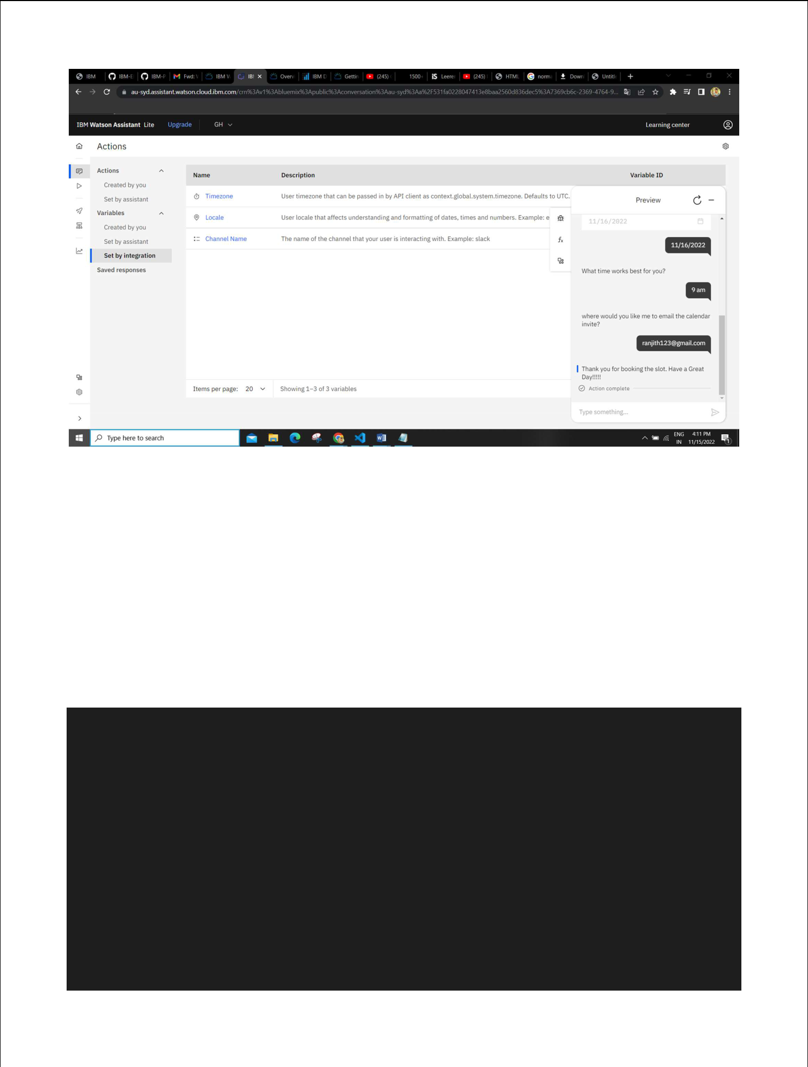

- Create Watson assistant service with 10 steps and use 3 conditions in it. Load that script in HTML page.

Html:

<head>

<title>Watson Assistant Preview</title>

<meta name="description" content="Preview of a Watson Assistant">

<meta http-equiv="Content-Type" content="text/html; charset=UTF-8">

<meta http-equiv="X-UA-Compatible" content="IE=edge,chrome=1">

<meta name="viewport" content="width=device-width,initial-scale=1">

<meta name="robots" content="none"><link rel="schema.dcterms"

href="http://purl.org/dc/terms/">

<meta name="dcterms.rightsHolder" content="IBM">

<meta name="dcterms.dateCopyrighted" content="2021">

<link rel="shortcut icon" href="https://web-

chat.global.assistant.watson.cloud.ibm.com/favicon.ico">

<link href="https://web-

chat.global.assistant.watson.appdomain.cloud/versions/6.8.1/previewCarbon.css"

rel="stylesheet">

<script defer="defer" src="preview.js?daf92ca7640c31568853"> </script>

<script src="https://web-

chat.global.assistant.watson.appdomain.cloud/versions/latest/WatsonAssistantChatE

ntry.js"></script>

</head>
